**CSE 2263: EMBEDDED SYSTEMS LAB Lab Question Bank**

# A. MASM Programs

1. To print hello world

1. To transfer 20 bytes of data from one mem loc to another

1. To exchange 10 bytes of data

1. To exchange 20 bytes of data

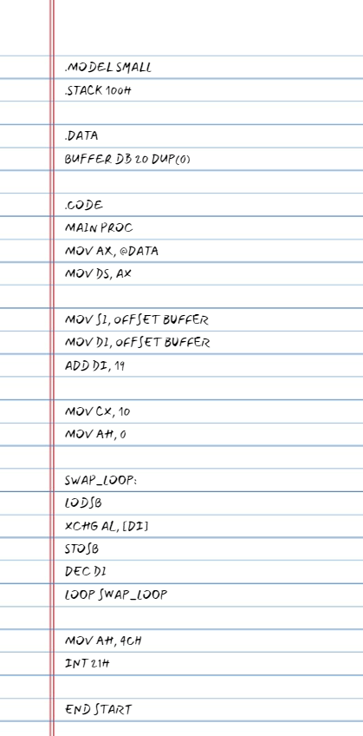

1. To add two 8-bit numbers method 1

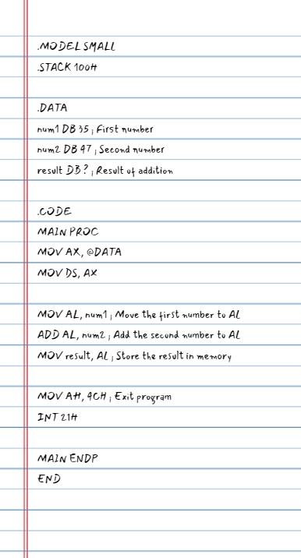

1. To add two 16-bit numbers using method 1

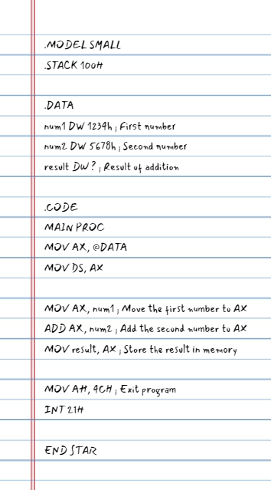

1. To add two 8-bit numbers using method 2

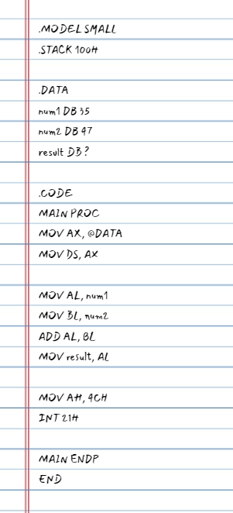

1. To add two 16-bit numbers using method 2
2. 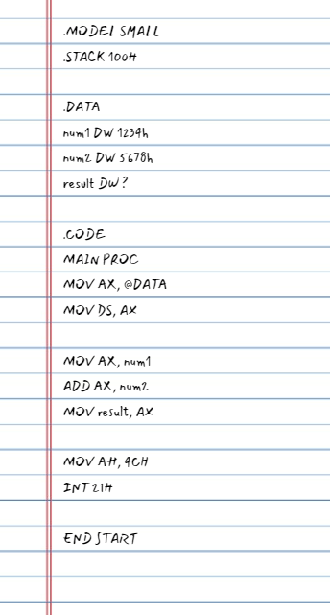
3. To transfer data into separatee memory loc based on even/odd numbers (using AND)
4. 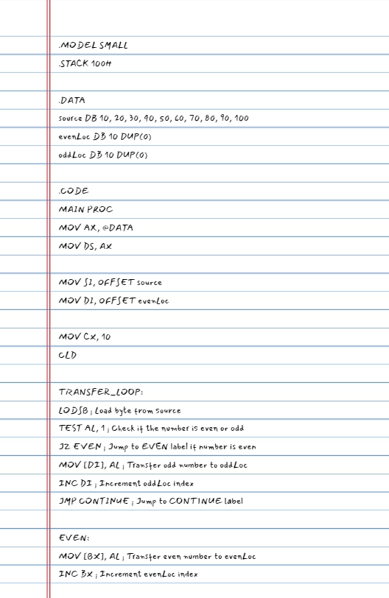

1. To check whether number is odd/even (using AND)

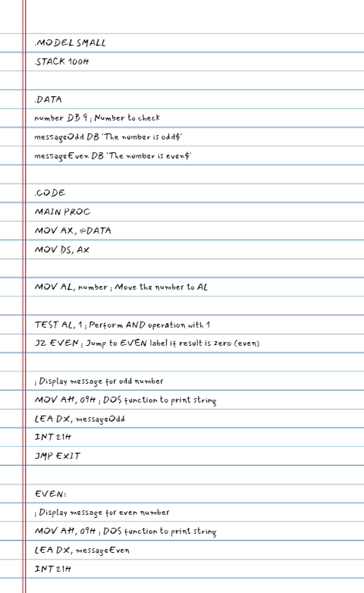

1. To check whether number is positive/negative (using AND)

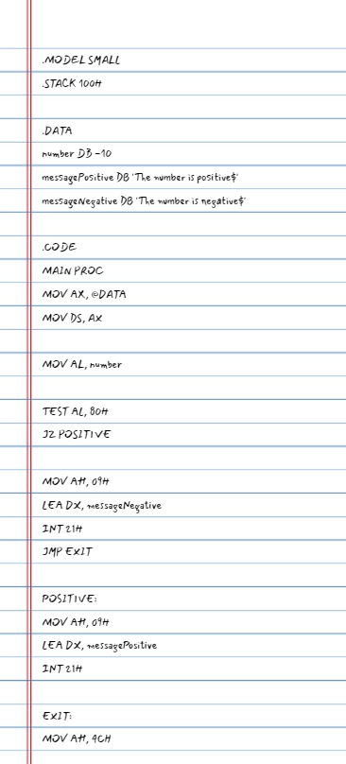

1. To transfer data into separate memory loc bases on positive /negative numbers (using AND)

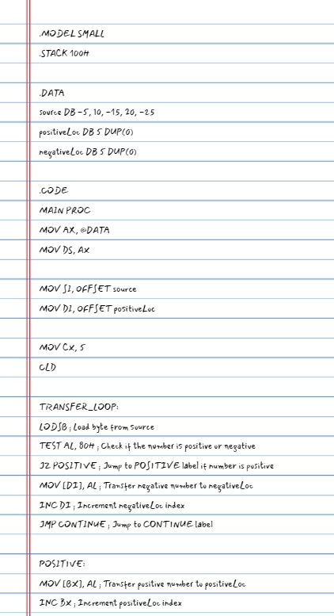

1. To print a char
2. 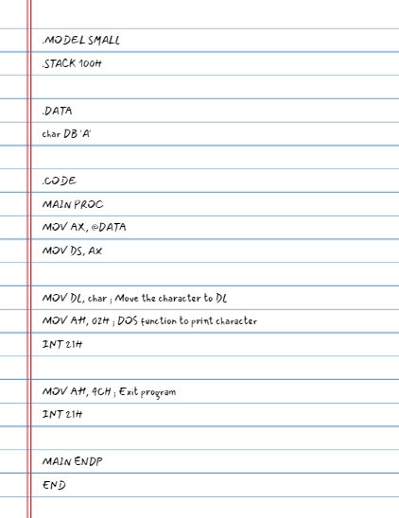
3. To print a number
4. A close-up of a notebook

   Description automatically generated with low confidence
5. To print array of ten 8 bit two-digit numbers
6. To print one 16-bit number
7. To print array of 10 16-bit numbers
8. To transfer data into separate memory loc based on even/odd numbers (using Rotate right with carry RCR)
9. To transfer data into separate memory loc based on positive /negative numbers (using Rotate right with carry RCR)
10. To reverse a given number
11. To print number in binary form
12. 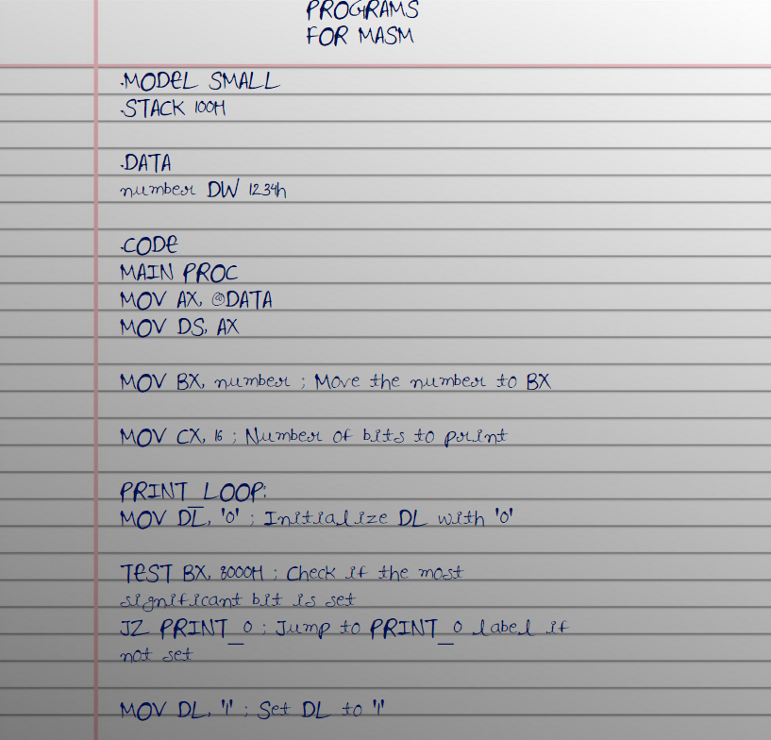
13. To input a number, print it and reverse the number, print it
14. To check whether number is odd/even (using ROR)
15. To check whether number is positive/negative (using ROR)
16. To transfer data into separate memory loc based on odd/even memory address sequence

(using ROR)

1. To input ten 2-digit numbers
2. To find largest in array
3. To find smallest in array
4. To sort in ascending
5. To sort in descending order
6. To input two 2-digit numbers and print their sum in the format (sum=12+34)
7. To position cursor in the middle and print char at cursor position
8. To scroll up? (Print at the specified position of cursor IDK?)
9. To check if number is 2-OUT OF-5 CODE
10. To input a number and check if its 2 out of 5 codes
11. To search for a number in an array
12. To count the number of occurrences of a number in an array
13. To check if two arrays are equal/identical.
14. To print a message using MACRO
15. To read, display number, print message using MACRO
16. To read a 2-digit number using MARCO
17. To read, display a number using PROCEDURE.
18. To read, display one 2digit number using PROCEDURE.
19. To read, display 10 2digit numbers using PROCEDURE.
20. To read elements of two and find the sum of their corresponding elements and store sum in a diff array.
21. To count the number of 1's in each of the numbers in an array X and store the count in array Y.
22. To check if number is palindrome or not.
23. To check if number is bitwise palindrome or not.
24. To input n 16-bit numbers
25. Write an ALP program to ask user to input a 2-digit number. Give user two options for count up and count down. If count up is chosen, display up count from the user input to FF. If count down is chosen, display down count from the user input to 00.

# B. 8086 KIT based programs

**a. Done without the interface.**

1. WAP to add 2 numbers and store result in 3rd location.
2. WAP to move data of 10 bytes from one location to another.
3. WAP to exchange content of an array of 10 bytes with another array of 10 bytes.
4. WAP to find largest in array.
5. WAP to find smallest in array.
6. WAP to sort array in ascending order.
7. WAP to sort array in descending order.
8. WAP to display 55 and AA alternatively on the kit screen.
9. WAP to display 00 to FF counter on the kit screen (HEX up counter).
10. WAP to display FF to 00 counter on the kit screen (HEX down counter).
11. WAP to display 00 to 99 counter on the kit screen (BCD up counter).
12. WAP to display 99 to 00 counter on the kit screen (BCD down counter).

**b. Programs done with the interface.**

**i. DIGITAL I/O:**

1. WAP to display 55 and AA.
2. WAP to read from switch, complement and send to Port A.
3. WAP for BCD up and down counter.
4. WAP for binary up and down counter.
5. WAP to display 00-FF.
6. WAP to display FF-00.
7. WAP to display 00-99.
8. WAP to display 99-00.
9. WAP to read from port B of 8255, separate higher nibble and lower nibble, multiply them and display product through Port A.

**ii. DAC:**

1. WAP to generate square waveform.

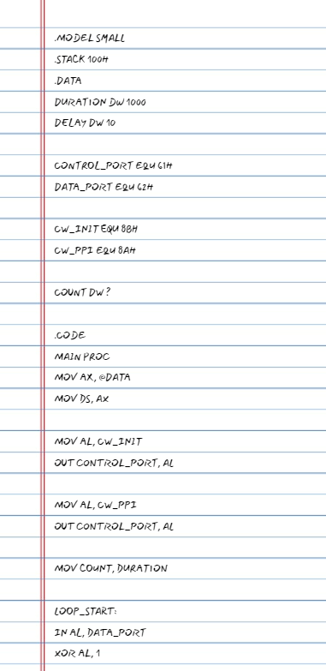

1. WAP to generate positive ramp waveform.
2. 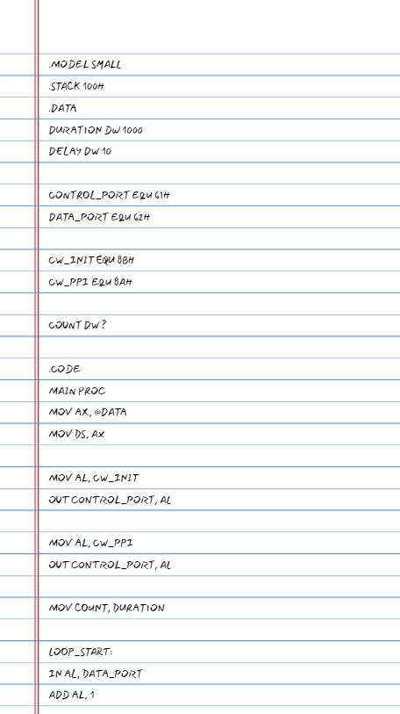

1. WAP to generate triangle waveform.
2. WAP to generate staircase waveform.
3. WAP to generate any given waveform (e.g., given below):

|  |  |  |  |
| --- | --- | --- | --- |
|  |  |  | |
|  | | |  |

**iii. STEPPER MOTOR:**

1. WAP to rotate motor by 90 degrees.
2. WAP to rotate motor clockwise, anti-clockwise.
3. WAP to rotate motor clockwise, anti-clockwise in 64 steps.

# STM32 NUCLEO BOARD STM32F303RE and STM32F401RE

1. WAP to blink LED (delay).
2. WAP to give input to micro-controller from switch, based on that turn on/off LED. 84. WAP to print 0-9 (7-SEGMENT DISPLAY)